**Assignment 1**

Addition in android studio

xml

<?xml version="1.0" encoding="utf-8"?>

<RelativeLayout xmlns:android="http://schemas.android.com/apk/res/android"

xmlns:app="http://schemas.android.com/apk/res-auto"

xmlns:tools="http://schemas.android.com/tools"

android:layout_width="match_parent"

android:layout_height="match_parent"

tools:context=".MainActivity">

<Button

android:id="@+id/button"

android:layout_width="wrap_content"

android:layout_height="wrap_content"

android:layout_alignParentEnd="true"

android:layout_alignParentBottom="true"

android:layout_marginEnd="296dp"

android:layout_marginBottom="377dp"

android:text="Add"

app:layout_constraintEnd_toEndOf="parent"

app:layout_constraintHorizontal_bias="0.117"

app:layout_constraintStart_toStartOf="parent"

tools:layout_editor_absoluteY="284dp" />

<EditText

android:id="@+id/val1"

android:layout_width="wrap_content"

android:layout_height="wrap_content"

android:layout_alignParentEnd="true"

android:layout_alignParentBottom="true"

android:layout_marginEnd="176dp"

android:layout_marginBottom="568dp"

android:ems="10"

android:inputType="textPersonName"

android:text=""

app:layout_constraintEnd_toEndOf="parent"

app:layout_constraintHorizontal_bias="0.164"

app:layout_constraintStart_toStartOf="parent"

tools:layout_editor_absoluteY="75dp" />

<EditText

android:id="@+id/val2"

android:layout_width="wrap_content"

android:layout_height="wrap_content"

android:layout_alignParentEnd="true"

android:layout_alignParentBottom="true"

android:layout_marginEnd="179dp"

android:layout_marginBottom="499dp"

android:ems="10"

android:inputType="textPersonName"

android:text=""

app:layout_constraintEnd_toEndOf="parent"

app:layout_constraintHorizontal_bias="0.164"

app:layout_constraintStart_toStartOf="parent"

tools:layout_editor_absoluteY="143dp" />

<TextView

android:id="@+id/result"

android:layout_width="wrap_content"

android:layout_height="wrap_content"

android:layout_alignParentEnd="true"

android:layout_alignParentBottom="true"

android:layout_marginEnd="383dp"

android:layout_marginBottom="446dp"

android:text=""

app:layout_constraintEnd_toEndOf="parent"

app:layout_constraintHorizontal_bias="0.093"

app:layout_constraintStart_toStartOf="parent"

tools:layout_editor_absoluteY="221dp" />

</RelativeLayout>

MainActivity.java

package com.example.a17_07_2024_androidlecture;

import androidx.appcompat.app.AppCompatActivity;

import android.os.Bundle;

import android.view.View;

import android.widget.Button;

import android.widget.EditText;

import android.widget.TextView;

public class MainActivity extends AppCompatActivity {

@Override

protected void onCreate(Bundle savedInstanceState) {

super.onCreate(savedInstanceState);

setContentView(R.layout.activity_main);

EditText ed1=(EditText) findViewById(R.id.val1);

EditText ed2=(EditText) findViewById(R.id.val2);

TextView te=(TextView) findViewById(R.id.result);

Button b=(Button) findViewById(R.id.button);

b.setOnClickListener(new View.OnClickListener() {

@Override

public void onClick(View view) {

int a = Integer.parseInt(ed1.getText().toString());

int b = Integer.parseInt(ed2.getText().toString());

int res;

res=a+b;

String s;

s=Integer.toString(res);

te.setText(s);

}

});

}

}

Output:

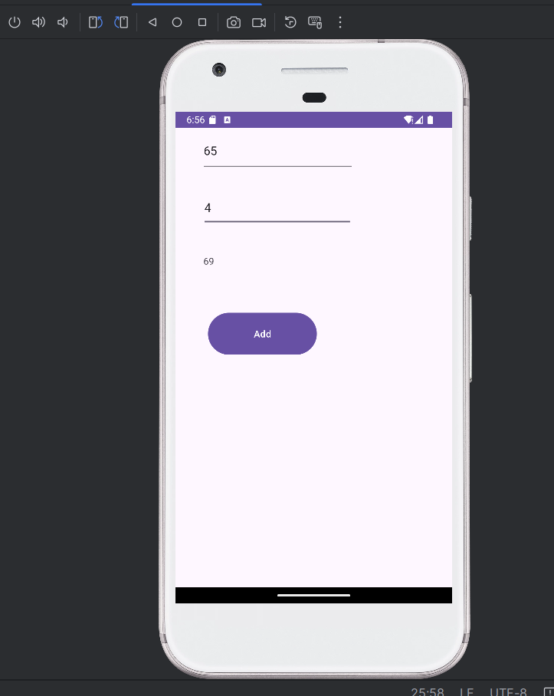

**Assignment 2**

Basic Calculator in Android Studio

Xml

<?xml version="1.0" encoding="utf-8"?>

<RelativeLayout xmlns:android="http://schemas.android.com/apk/res/android"

xmlns:tools="http://schemas.android.com/tools"

android:layout_width="match_parent"

android:layout_height="match_parent"

tools:context=".MainActivity">

<EditText

android:id="@+id/val1"

android:layout_width="wrap_content"

android:layout_height="wrap_content"

android:hint="Value 1"

android:inputType="number"

android:layout_marginTop="50dp"

android:layout_centerHorizontal="true"/>

<EditText

android:id="@+id/val2"

android:layout_width="wrap_content"

android:layout_height="wrap_content"

android:hint="Value 2"

android:inputType="number"

android:layout_below="@id/val1"

android:layout_marginTop="20dp"

android:layout_centerHorizontal="true"/>

<TextView

android:id="@+id/res"

android:layout_width="wrap_content"

android:layout_height="wrap_content"

android:text="Result"

android:textSize="20sp"

android:layout_below="@id/val2"

android:layout_marginTop="20dp"

android:layout_centerHorizontal="true"/>

<Button

android:id="@+id/button_add"

android:layout_width="wrap_content"

android:layout_height="wrap_content"

android:text="Add"

android:layout_below="@id/res"

android:layout_marginTop="20dp"

android:layout_centerHorizontal="true"/>

<Button

android:id="@+id/button_sub"

android:layout_width="wrap_content"

android:layout_height="wrap_content"

android:text="Subtract"

android:layout_below="@id/button_add"

android:layout_marginTop="10dp"

android:layout_centerHorizontal="true"/>

<Button

android:id="@+id/button_mul"

android:layout_width="wrap_content"

android:layout_height="wrap_content"

android:text="Multiply"

android:layout_below="@id/button_sub"

android:layout_marginTop="10dp"

android:layout_centerHorizontal="true"/>

<Button

android:id="@+id/button_div"

android:layout_width="wrap_content"

android:layout_height="wrap_content"

android:text="Divide"

android:layout_below="@id/button_mul"

android:layout_marginTop="10dp"

android:layout_centerHorizontal="true"/>

</RelativeLayout>

MainActivity.java

package com.example.assignment2;

import androidx.appcompat.app.AppCompatActivity;

import android.os.Bundle;

import android.view.View;

import android.widget.Button;

import android.widget.EditText;

import android.widget.TextView;

public class MainActivity extends AppCompatActivity {

@Override

protected void onCreate(Bundle savedInstanceState) {

super.onCreate(savedInstanceState);

setContentView(R.layout.activity_main);

EditText ed1 = (EditText) findViewById(R.id.val1);

EditText ed2 = (EditText) findViewById(R.id.val2);

TextView te = (TextView) findViewById(R.id.res);

Button addButton = (Button) findViewById(R.id.button_add);

Button subButton = (Button) findViewById(R.id.button_sub);

Button mulButton = (Button) findViewById(R.id.button_mul);

Button divButton = (Button) findViewById(R.id.button_div);

addButton.setOnClickListener(new View.OnClickListener() {

@Override

public void onClick(View view) {

int a = Integer.parseInt(ed1.getText().toString());

int b = Integer.parseInt(ed2.getText().toString());

int res = a + b;

te.setText(Integer.toString(res));

}

});

subButton.setOnClickListener(new View.OnClickListener() {

@Override

public void onClick(View view) {

int a = Integer.parseInt(ed1.getText().toString());

int b = Integer.parseInt(ed2.getText().toString());

int res = a - b;

te.setText(Integer.toString(res));

}

});

mulButton.setOnClickListener(new View.OnClickListener() {

@Override

public void onClick(View view) {

int a = Integer.parseInt(ed1.getText().toString());

int b = Integer.parseInt(ed2.getText().toString());

int res = a * b;

te.setText(Integer.toString(res));

}

});

divButton.setOnClickListener(new View.OnClickListener() {

@Override

public void onClick(View view) {

int a = Integer.parseInt(ed1.getText().toString());

int b = Integer.parseInt(ed2.getText().toString());

if (b != 0) {

int res = a / b;

te.setText(Integer.toString(res));

} else {

te.setText("Cannot divide by zero");

}

}

});

}

}

Output:

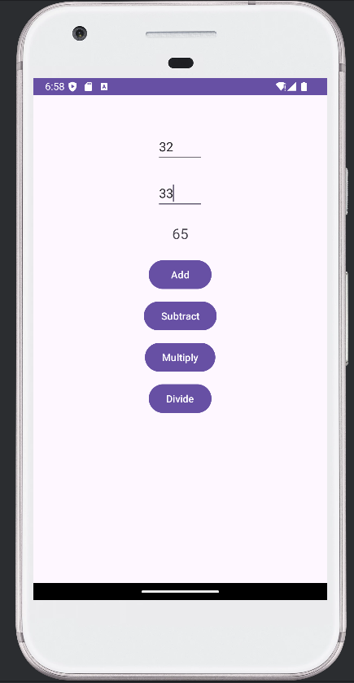 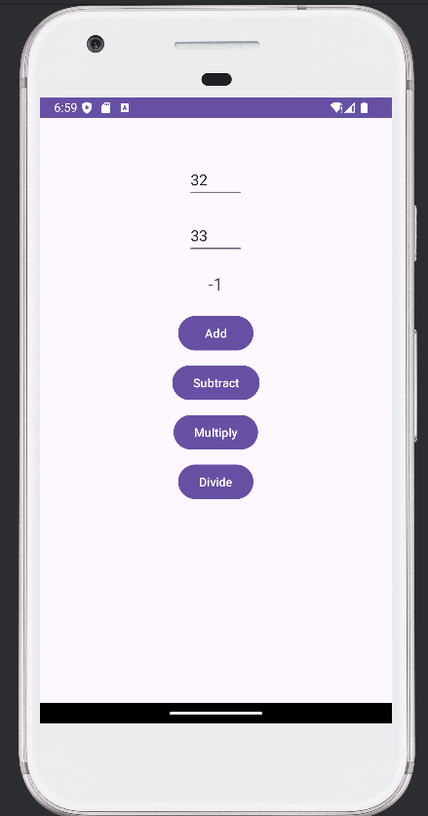

Addition Subtraction

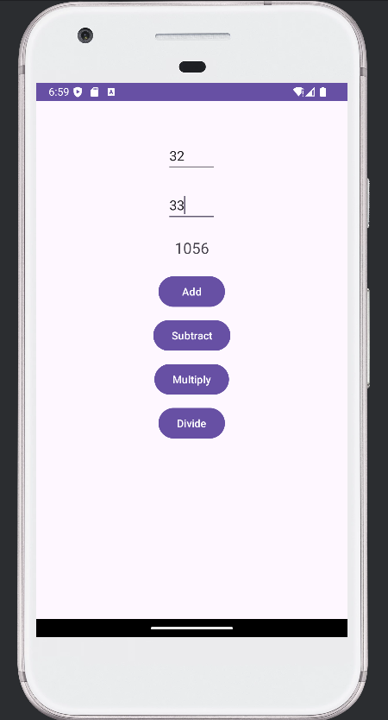 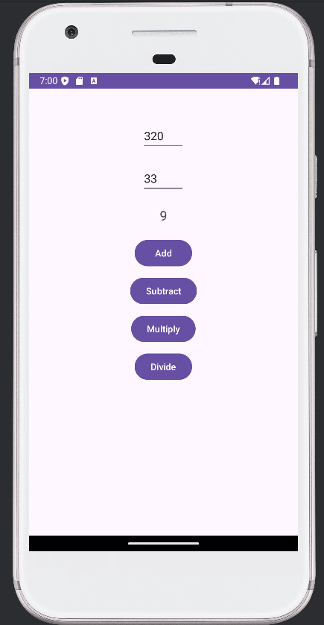

Multiplication Divide

**Assignment 3**

Activity Lifecycle operations

Xml

<?xml version="1.0" encoding="utf-8"?>

<androidx.constraintlayout.widget.ConstraintLayout xmlns:android="http://schemas.android.com/apk/res/android"

xmlns:app="http://schemas.android.com/apk/res-auto"

xmlns:tools="http://schemas.android.com/tools"

android:id="@+id/main"

android:layout_width="match_parent"

android:layout_height="match_parent"

tools:context=".MainActivity">

<TextView

android:layout_width="wrap_content"

android:layout_height="wrap_content"

android:text="Hello World!"

app:layout_constraintBottom_toBottomOf="parent"

app:layout_constraintEnd_toEndOf="parent"

app:layout_constraintStart_toStartOf="parent"

app:layout_constraintTop_toTopOf="parent" />

</androidx.constraintlayout.widget.ConstraintLayout>

MainActicity.java

package com.example.assignment3;

import android.os.Bundle;

import androidx.activity.EdgeToEdge;

import androidx.appcompat.app.AppCompatActivity;

import androidx.core.graphics.Insets;

import androidx.core.view.ViewCompat;

import androidx.core.view.WindowInsetsCompat;

import android.util.Log;

public class MainActivity extends AppCompatActivity {

private static final String msg = "MainActivity";

@Override

protected void onCreate(Bundle savedInstanceState) {

super.onCreate(savedInstanceState);

EdgeToEdge.enable(this);

setContentView(R.layout.activity_main);

ViewCompat.setOnApplyWindowInsetsListener(findViewById(R.id.main), (v, insets) -> {

Insets systemBars = insets.getInsets(WindowInsetsCompat.Type.systemBars());

v.setPadding(systemBars.left, systemBars.top, systemBars.right, systemBars.bottom);

return insets;

});

Log.d(msg, "onCreate called");

}

@Override

protected void onStart() {

super.onStart();

Log.d(msg, "onStart called");

}

@Override

protected void onResume() {

super.onResume();

Log.d(msg, "onResume called");

}

@Override

protected void onPause() {

super.onPause();

Log.d(msg, "onPause called");

}

@Override

protected void onStop() {

super.onStop();

Log.d(msg, "onStop called");

}

@Override

protected void onDestroy() {

super.onDestroy();

Log.d(msg, "onDestroy called");

}

}

Output:

Logcat

